1

CO101 Project Report on

PHONEBOOK

*submitted towards the partial fulfillment of the requirement for the award of the degree of*

Bachelor of Technology in

**SOFTWARE ENGINEERING**

Submitted by

**RAGHAV KUMAR JHA 2K20/B9/04 SANDALI SINGH 2K20/B9/16**

*Under the Supervision of*

Sir Ashish Girdhar



Department of Computer Science and Engineering Delhi Technological University

Bawana Road. Delhi -110042

# DECLARATION

We, (RAGHAV KUMAR JHA 2K20/B9/04, SANDALI SINGH 2K20/B9/16) students of B.

Tech. (Software Engg.) hereby declare that the project titled ”PHONEBOOK” in partial fulfilment of the requirement for the award of the degree of Bachelor of Technology and submitted to the Department of Computer Science and Engineering, Delhi Technological University, Delhi is carried out under the supervision of our subject teacher Ashsish Girdhar.

RAGHAV KUMAR JHA 2K20/B9/04 SANDALI SINGH 2K20/B9/16

Software Engineering

## ACKNOWLEDGEMENT

In performing our major project, we had to take the help and guideline of some respected persons, who deserve our greatest gratitude. The completion of this assignment gives us much pleasure. We would like to show our gratitude to Ashish Girdhar, Mentor for the major project. Giving us a good guideline for report throughout numerous consultations. We thank all the people for their help directly and indirectly to complete our assignment. In addition, we would like to thank the Department of Computer Science and Engineering, Delhi Technological University for giving us the opportunity to work on this topic.

# ABSTRACT

Phonebook is a very simple mini project in C. The concept of **file management, Data Structures and functions** are used in this project. It **adds new records, lists them, modifies**

**them, searches them and deletes them.** These are the basic functions which make up the main menu of this phonebook application. Personal information such as **Name, Phone No., Email,**

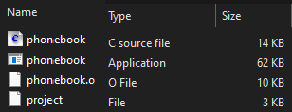**Date of Birth, Gender, Mother’s name, Father’s name, Nationality and Address** are required to add a Record to the phonebook.It is easy to understand and simple to use. This Program is very useful nowadays to store complete information under a single contact number. This mini phonebook design allows you to perform simple tasks in your phonebook, such as mobile phones.

# CONTENT

* AIM
* DETAILS
* DESIGN
* ALGORITHM and FLOWCHART
* CODE
* OUTPUT SCREENS
* ADVANTAGES
* CONCLUSION

# INTRODUCTION

To develop a ‘PHONEBOOK’ application using C programming.

Phonebook is a very simple mini project in C . The concepts of file handling, data structures and functions are extensively used in this project.Personal information like Name, Phone No, Email, Date of Birth, Gender, Mother’s Name, Father’s Name, Nationality and Address are required to add a record to the phonebook.You can do operations like insert a record , modify, list as well as you can also do a search and delete operations. There is an exit option as well.

# DETAILS

This phonebook application is coded and made using Dev C and Code Blocks and GCC compiler. The application size is 61Kb and size of source file is 10Kb.

# DESIGN

The present program consists of the following modules: Preprocessor commands, Structure, Function, Variables, Pointers, Array, Iterative Control Instructions i.e. Loops, Decision Control instructions i.e If-else, Switch-case Control Instructions, Statements and expressions and File Handling.

# ALGORITHM

1. START
2. Print “WELCOME TO PHONEBOOK” and “Menu” on the screen.
   1. Add contact, go to (3)
   2. List contact, go to (4)
   3. Modify contact, go to (5)
   4. Search contact, go to (6)
   5. Delete contact, go to (7)
   6. Exit phonebook, to STOP Take input from the user.
3. For Addrecord(), ask the user to Enter name, phone number, email id, Date of birth, gender, mother’s name, father’s name, nationality, address and write it in the file project. Enter any key to go to the menu.
4. For Listrecords(), arranging data as
   1. If unable to open file, print error.
   2. Else, display name, phone number, email id, DOB, gender, mother’s name, father’s name, nationality, address from the file.

Then, print enter any key to go to the main menu.

1. For Modifyrecord(),
   1. If unable to open file, print error.
   2. Else, Enter contact’s name to modify
      1. If contact found in file
         1. Input name, phone number, email id, date of birth, gender, mother’s name, father’s name, nationality, address from user. Rewrite the input data in place of the contact to be modified in the file.
         2. Then, display your data is modified
      2. Else, Print data is not found

Display enter any key to go to the main menu.

1. For searchrecord(),
   1. If unable to open file, print error.
   2. Else, input name of contact to be searched from user and
2. If contact found in file, display name, phone number, email id, date of birth, gender, mother’s name, father’s name, nationality, address of the contact
3. Else, display contact not found. Then, print enter any key to go to main menu
4. Now for deleterecord(),
   1. If unable to open file, print error.
   2. lse, input name of contact to be deleted from user Initiate a loop from start to end of file project
      1. If contact found, flag=1. Display the info of the contact.
      2. Else, copy the record to file temp

c. if (flag!=1)

1. Print no contact’s record to be deleted.
2. Else, Print record deleted successfully. Delete the file project and rename temp to project file.

d. Then, ask the user to press any key to go to the menu.

# FLOWCHART

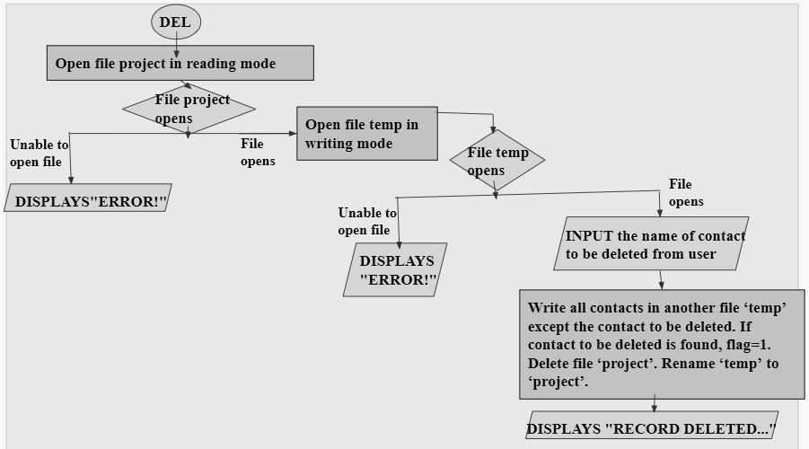

**USE OF HEADER FILES**

* **stdio.h**- Standard input and output header file. It has definitions of functions like printf() and scanf(). It takes an input from the user and displays output either in a file or console. We also used fflush(), fclose(), fopen(),and remove().
* **string.h**- It contains macro definitions, constants, and declaration of functions and types used not only for string handling but also memory handling functions. We have used strcmp() to compare the input name and saved records in searchrecord() function.
* **windows.h**- It is a windows specific header file for the c and c++ programming languages which contains declarations for all the functions in windows API, all the common macros used by windows programmers, and all the data types used by the various functions and subsystems. We have used setcontrolcursorpostion() to display MENU at the center of the output screen.
* **conio.h**- We have used getch() in our program.
* 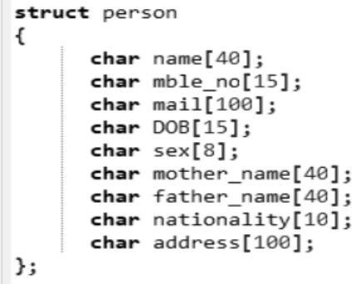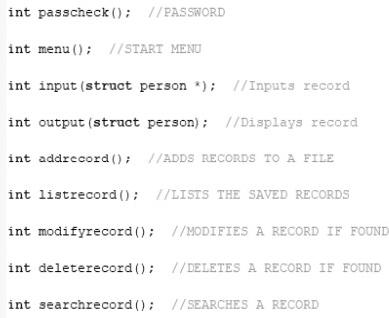**stdlib.h**- We have used exit() to stop the program when the user asks.

# SOURCE CODE

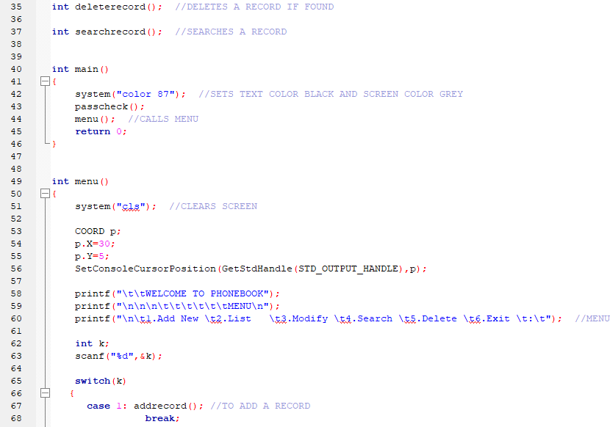

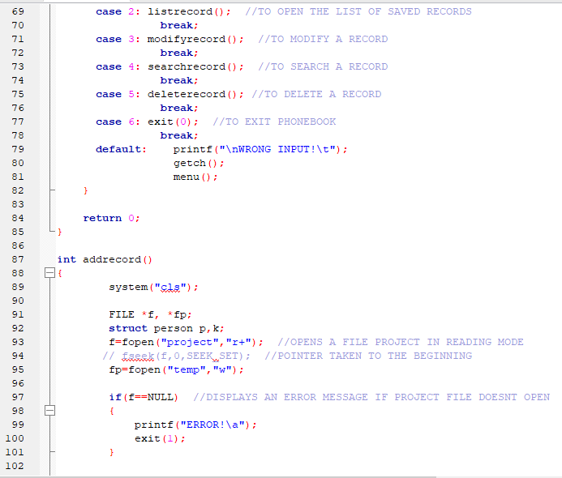

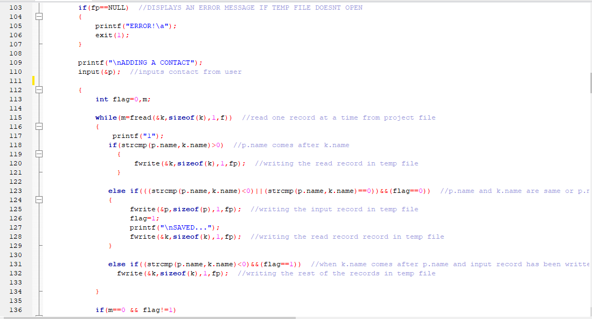

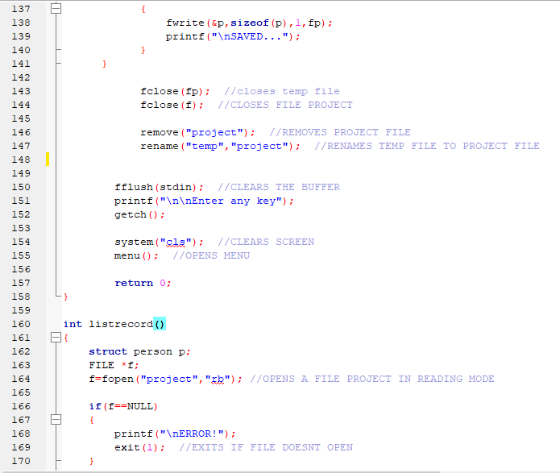

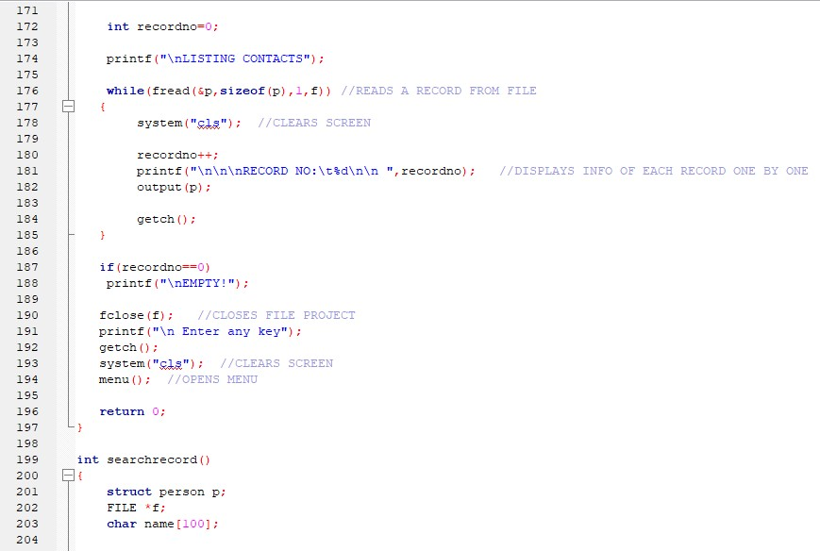

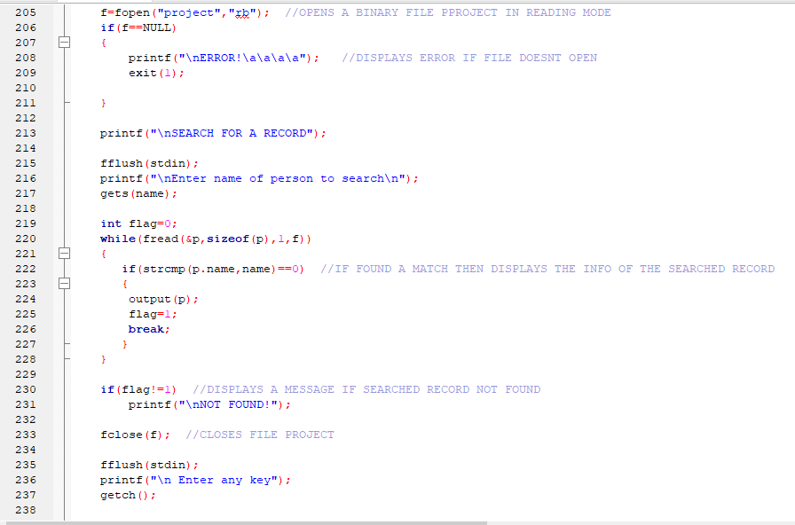

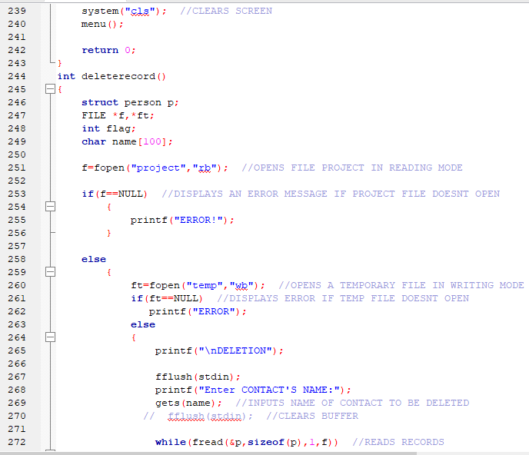

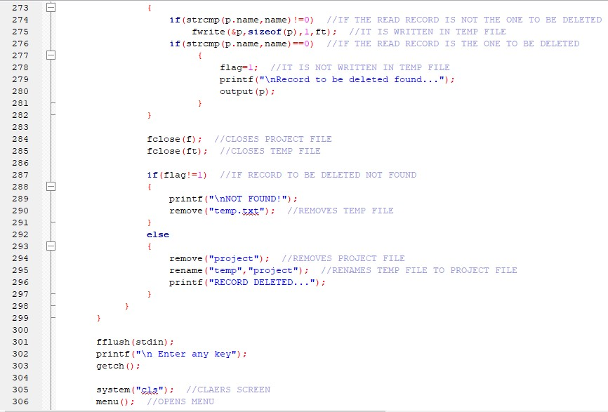

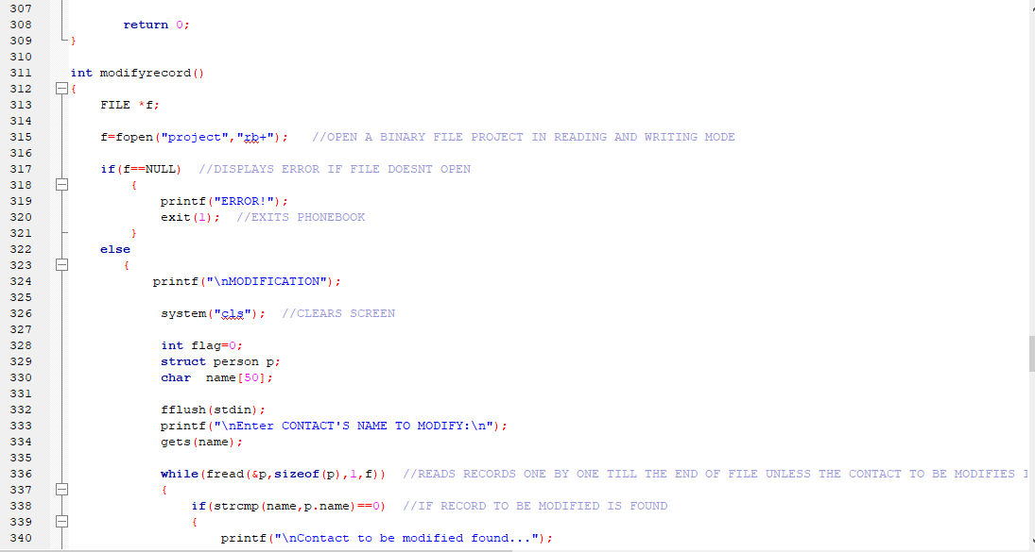

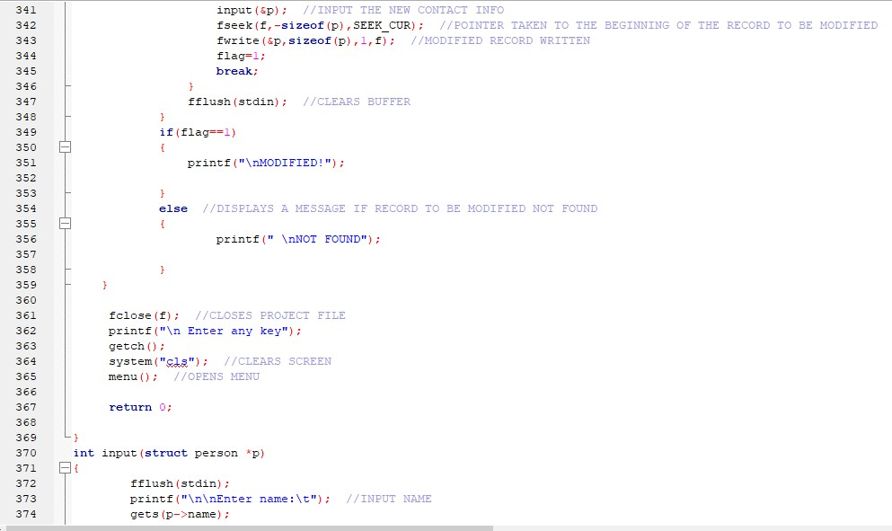

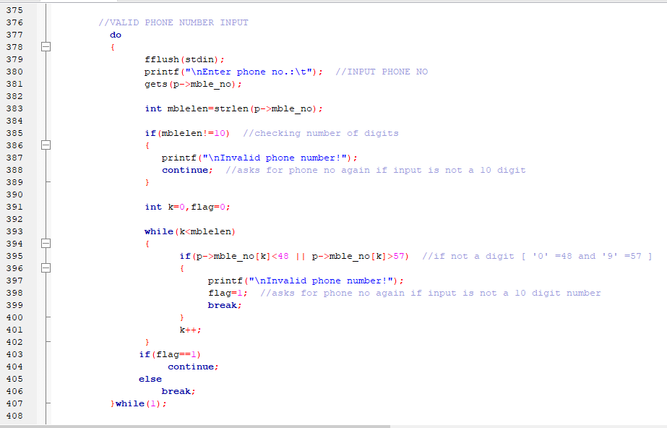

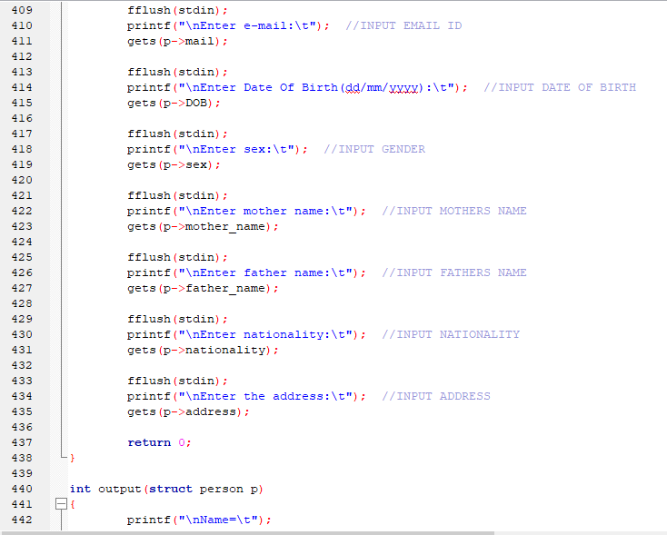

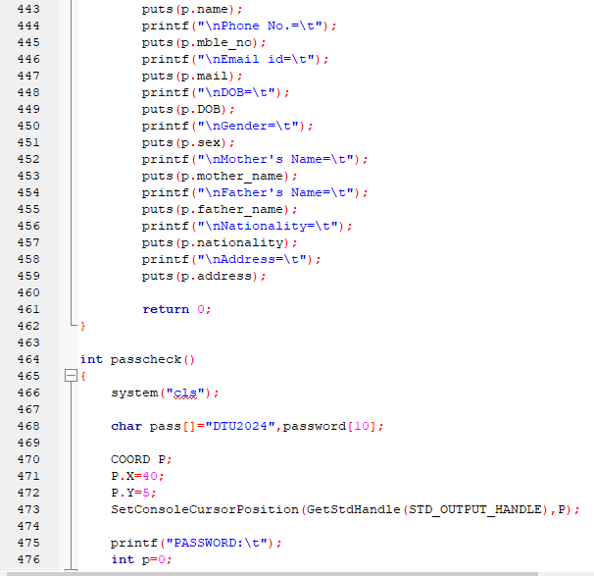

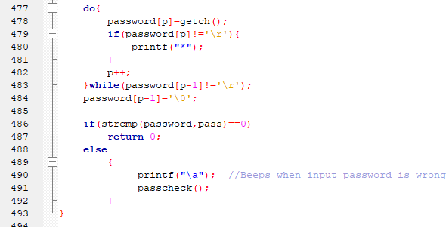

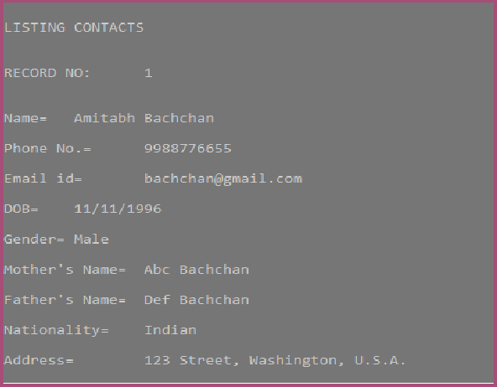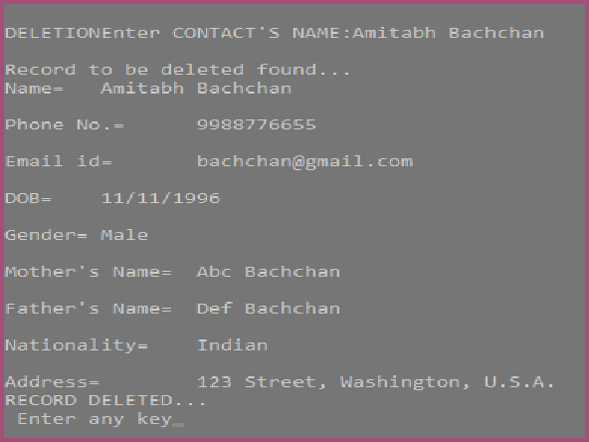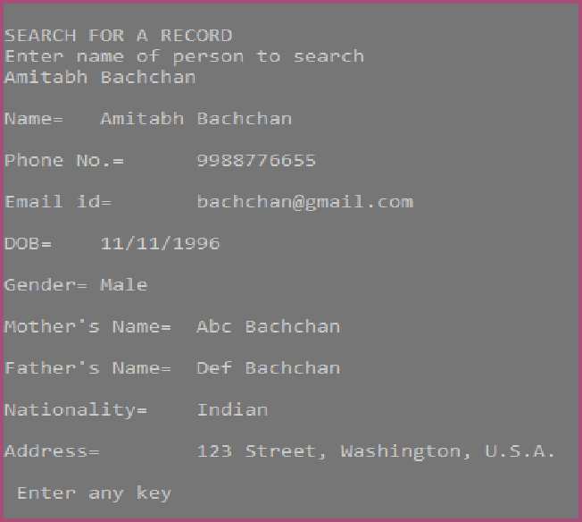

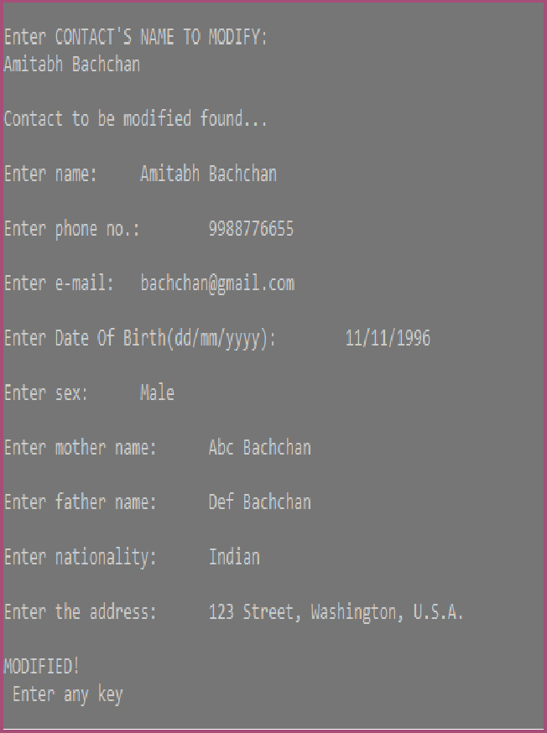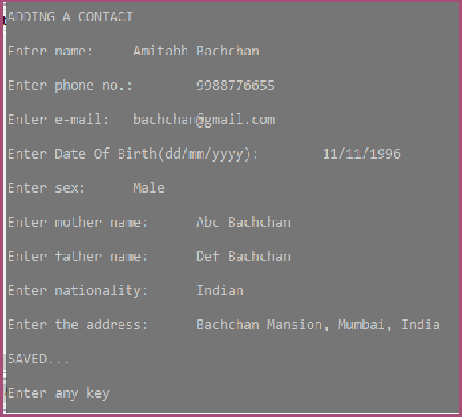**OUTPUT**

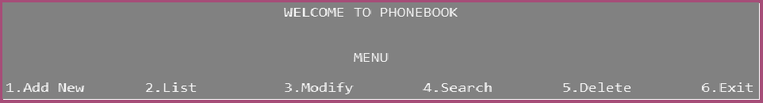

**ADVANTAGES**

* It becomes easy for the user to store complete information (i.e. Email id, Address, etc.) about his contact.
* It is easy for the user to just search his required contact number by just typing the name of the contact.
* If there are two or more contacts with the same name, when searched the program shows both the records.

# DISADVANTAGES

* Sometimes it becomes difficult to store more contacts (i.e. over 150).
* To search contact by phone no.

# CONCLUSION

This program makes the user simple to connect to his contact. The contact personal information and family information is stored under a single number this would benefit the user to easily search and locate his required contact. This program deals with five operations of adding contact, listing contact, modifying a contact, searching according to the user's choice and deleting them. Each operation made as an individual function and so control enters a different structure and all the data added, modified or deleted going to be stored in a .txt file using file pointer. With the help of this project we are able to understand the concept of file handling, data structure, control instruction etc. in a more efficient manner. This application can be used in many organisations to store staff and employees personal details.

